Financial Exchange Corp. – 1031 FEC www.1031FEC.com 800-333-0801

The most common 1031 ‘three-way delayed exchange’

IRC Section 1031 stipulates that in order for an investor to defer capital gains taxes on profits realized from the sale of real estate, the relinquished property must be exchanged for "like-kind" replacement property. Some investors assume that this confines them to exchanging a condominium complex for another condominium complex, or an office building for a similarly used business facility.
In fact, the definition of "like-kind" is considerably broader. As long as a client exchanges "real property" held for investment or used in trade or business for any other "real property" to be used for this same range of purposes, it will qualify. While a primary residence or other property primarily held for personal use may not be exchanged, most other real estate can. For example, an investor could sell a rental town home and defer any capital gains taxes by reinvesting the sale proceeds into a warehouse.
A common type of 1031 Exchange, often referred to as a three-way delayed exchange, is outlined in the diagram below.
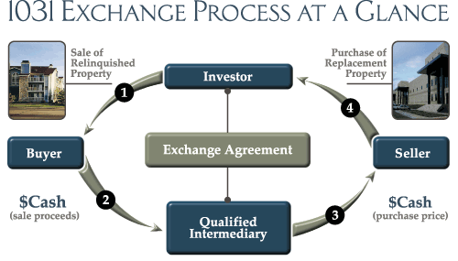
In order to successfully complete any 1031 exchange, you must follow specific IRS guidelines. Some key parameters to keep in mind are summarized below:
Use of a "Qualified Intermediary"
A "qualified intermediary" must be engaged to help complete the 1031 Exchange. Furthermore, you need to include specific exchange language within the sales contract (for the relinquished property), allowing certain rights under the sales contract, including the right to receive the sale proceeds, to be assigned to the selected intermediary. A nationally-recognized intermediary will hold all of the sale proceeds for the investor and assist him or her throughout the process.
Completion of the Exchange within a Certain Period
If an investor decides to take advantage of a 1031 Exchange, he or she must identify potential replacement properties within 45 days from the sale date of the relinquished property. The acquisition of one or more replacement properties must be completed within 180 days from the date the relinquished property was sold.
Full Reinvestment
If an investor wishes to fully defer capital gains taxes, he or she must reinvest all of the net proceeds from the relinquished property sale. Additionally, the dollar amount of debt associated with the replacement property must be at least equal to the dollar amount of debt repaid on the sale of the relinquished property, unless the investor opts to contribute additional cash to cover such debt. For example, if an investor sells a property for $1,000,000 on which he or she held a $400,000 mortgage, $600,000 would remain in the qualified-intermediary account after paying off the loan. However, in order to fully defer paying capital gains tax, the investor would be required to invest not just $600,000, but rather the full $1,000,000 amount in a replacement property. The investor could do so by initiating or assuming a new $400,000 mortgage or by contributing $400,000 of additional cash.
For more information, email or call 1031 FEC at 800-333-0801.

