Financial Exchange Corp. – 1031 FEC www.1031FEC.com 800-333-0801
Additional Flexibility With Section 721

Like a 1031 Exchange, a 721 exchange is also an effective vehicle for deferring capital gains taxes. So what differentiates a 721 Exchange? Instead of selling an investment property and exchanging it for another as prescribed under Section 1031, an investor using Section 721 contributes his or her property to a partnership. In turn, he or she receives interests in the partnership called operating partnership units (OP units).
721 Exchanges are often used by real estate investment trusts (REITs), which typically own all or substantially all of their assets through a subsidiary partnership with the REIT acting as general partner. The resulting corporate structure is called an umbrella partnership real estate investment trust, or UPREIT.
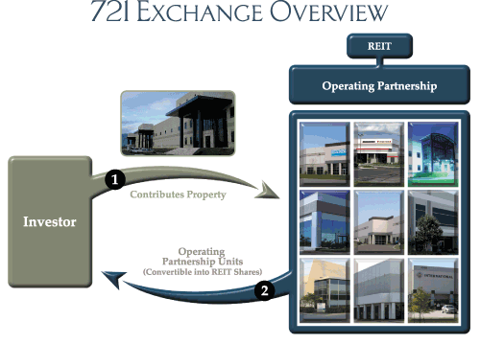
In a 721 Exchange, rather than taking possession of another property, investors receive OP units that carry the economic benefits of the REIT's entire portfolio, including capital appreciation and distributions of operating income. OP units can be converted later into shares of the associated REIT, and are only taxable when such a conversion or liquidation takes place.
For more information, email or call 1031 FEC at 800-333-0801.

